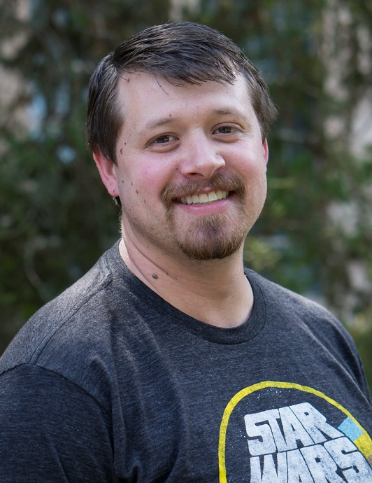

Jacob Siems
Winter 2018

Computer Room Consultant
of the Quarter
Olson

 | Alex Collazo  Fall 2017 | 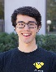 | Truman Williams  Spring 2017 | 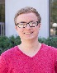 | Eric Jones  Winter 2017
 | Truman Williams  Fall 2016 | 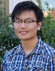 | Will Tien  Spring 2016 |  | Grecia Cruz  Winter 2016
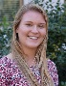 | Alexis Molgaard  Fall 2015 | 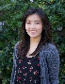 | Karina Chan  Spring 2015 | 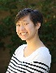 | Michelle Hoang  Winter 2015

Computer Lab Management
IET-Academic Technology Services

